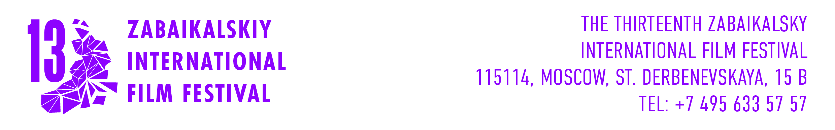
APPLICATION FOR PARTICIPATION
IN THE OFFICIAL COMPETITION OF
XIII ZABAIKALSKY INTERNATIONAL FILM FESTIVAL
MAY 21 – MAY 24th, 2026
Original title
English title
Producer
Director
Production company
Company contact | phone
Company contact | E-mail
Year of production
Duration
Format
Screener link
Synopsys

Filled application and screener are accepted on director@zmkf.ru until May, 10th 2026 Files should be less 5Gb or as a link to encrypted source.

