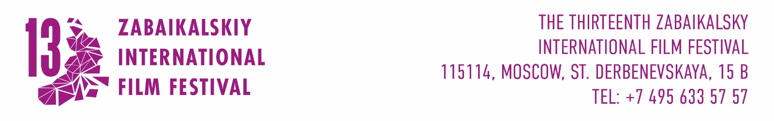

APPLICATION FOR PARTICIPATION
IN THE OFFICIAL SHORTS COMPETITION OF
THIRTEENTH ZABAIKALSKY INTERNATIONAL FILM FESTIVAL
MAY 21 – MAY 24th, 2026
Title
Director
Synopsis
Contacts
Production/ Distribution
Year of production
Duration
Format
Additional information

Filled application and screener are accepted on info@zmkf.ru until May, 10th 2026
Files should be less 2Gb or as a link to encrypted source.

